5.1 Angles & Their Measures

An angle is determined by rotating array at its endpoint.

Starting side is initial – ending side is terminal
Endpoint of ray is the vertex of angle.
Origin = vertex
Standard Position: When an angle is at the origin and its initial side lies
along the positive x-axis.
Positive angles: counter-clockwise Negative angles: clockwise

Quadrantal Angle: An angle whose terminal side lies on the x-axis
or the y-axis

Measurement of angle is amount of rotation from initial side to terminal side.

Draw each angle in standard position:
a) 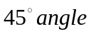 b) 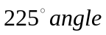 c) 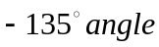c. d) 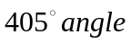

Radians: One radian is the measure of a central angle that intercepts an arc equal in length to the radius of the circle.

Just over 6 radians in a full circle hence 2
Make sure to make clear in radians is 180 degrees and as a distance is 3.14…..

Because the radian measure of an angle of one full revolution is 2 you obtain.
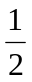revolution 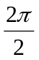= radians = 180 degrees

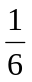revolution 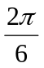= 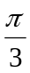 radians = 60 degrees

Degrees: – 1 degree is equivalent to a rotation of 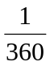 a revolution about the vertex.
360 degrees = 2 radians

All angles can be broken down into minutes and seconds where 60 minutes equal one degree and 60 seconds equals one minute. This helps to get a more precise angle measure.

You can find this under the ANGLE button on your calculator (DMS-degrees-minutes-seconds)

How to convert from Degrees to Radians: radians = 1 degree = 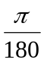

How to convert from Radians to Degrees: degrees = 1 radian = 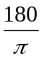degrees

Convert to Radians:

a. 45° b. 150° c. 72° d. 270° e. 99°

Convert to Degrees:

a. 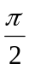 b. 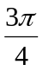 c. 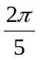 d. 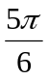 e. 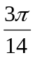

Coterminal: An angle of is coterminal with angles of , where k is an
integer. Coterminal angles have the same initial sides and terminal sides.

Ex: 0 and 2 are coterminal
Ex: 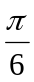and 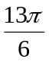 are coterminal.

Determine two coterminal angles for each:

a. 165° b. 420° c. -120° d. – 135°

- positive angles you will subtract 2

b) negative angles you will add 2 – 2 =

Reference angle: is the acute angle formed by the terminal side of and the horizontal axis.
What are the reference angles?

1) -45 degrees 5)

2) 200 degrees 6) 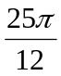

3) 123 degrees 7) 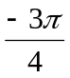

4) -400 degrees 8) 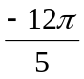

HW: Worksheet 1

5.1 Practice Worksheet

I. If each angle has the given measure and is in standard position, determine the Quadrant in which each its’ terminal side lies.

1. 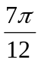 2. 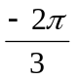 3. 371° 4. 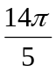

5. -156° 6. 1000° 7. 332° 8. 240°

II. Write each measure in radians. Express your answer in terms of π .

1. 36° 2. -250° 3. -145° 4. 6°

5. 870° 6. 18° 7. -820° 8. 345°

III. Write each measure in degrees.

1. 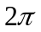 2. 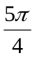 3. 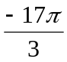 4. 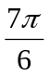

5. 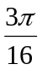 6. 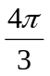 7. -2.56 8. 12.85

IV. Give the positive angle or negative angle that is coterminal with each angle between
-360° and 360° or 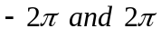, if given initially in radians.

1. 70° 2. -300° 3. 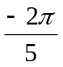 4.

V. Find the measure of the reference angle for each given angle. Remember it must be acute!

1. -20° 2. 160° 3. -545° 4. 300°

5. 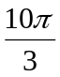 6. 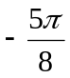 7. 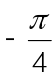 8. 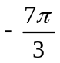

5.2 Central Angles and Arcs Notes

Central Angles: is an angle whose vertex lies at the center of the circle

Length of an Arc: the length of any circular arc, s, is equal to the product of the measure of the radius of the circle, r, and the radian measure of the central angle,, that it subtends. 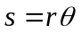

1. A circle has a radius of 6 inches. Find the length of the arc intercepted by a central angle of 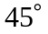.

2. A circle has a radius of 5cm. Find the length of the arc intercepted by a central angle of 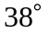

3. A circle has a radius of 10 ft. Find the length of the arc intercepted by a central angle of 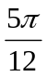.

4. A circle has a radius of 8 in. Find the length of the arc intercepted by a central angle of 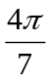.

5. Find the degree measure to the nearest tenth of the central angle that has an arc length of 87 and a radius of
16 cm.

6. Find the degree measure to the nearest tenth of the central angle that has an arc length of 5.6 and a radius of
12 cm.

Sector of a circle: A region bounded by a central angle and the intercepted arc. (A piece of PIE)

Area of a Circular Sector: If is the measure of the central angle expressed in radians and r is the measure of the radius
of the circle, then the area of the sector, A, is as follows.
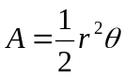
7. Find the area of the sector of the circle that has a central angle measure of 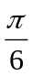 and a radius of 14 cm.

8. A sector has arc length 12 cm and a central angle measuring 1.25 radians. Find the radius and the area of the sector.

Nearest Degrees, Minutes, and Seconds: A degree of an angle can be broken down into minutes and seconds.
There are 60 minutes in a degree, and 60 seconds in a minute.
Finding values using a calculator:

a. 133.47° b. -321.81 c. 3.85 rads d. 1.06 rads

Trig Ratios:

sinθ = cosθ = tanθ =

Reciprocals:

Hint: Every function pair has a “co” in it.
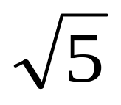
5
12
4

sinθ = cscθ = sinθ = cscθ =
cosθ = secθ = cosθ = secθ =
tanθ = cotθ = tanθ = cotθ =

sin45° = cos45° = tan45° =
Equilateral Triangle:

sin30° = sin60° =
cos30° = cos60° =
tan30° = tan60° =

5.2 Practice Worksheet
I. Given the radian measure of a central angle, find the measure of its intercepted arc in terms of
in a circle of radius 10 cm.

- 2. 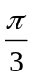 3. 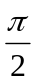 4. 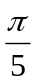

5. 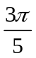 6. 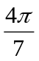 7. 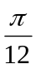 8. 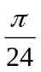

II. Given the measurement of a central angle, find the measure of its intercepted arc in terms of
in a circle of diameter 60 in.

9. 10° 10. 60° 11. 42° 12. 50°

13. 72° 14. 110° 15. 35° 16. 65°

III. Given the measure of an arc, find the degree measure to the nearest tenth of the central angle in a circle of radius 16 cm.
17. 87 18. 5.6 19. 12 20. 25

21. 10.24 22. 7.9 23. 11 24. 6

IV. Find the area of each sector to the nearest tenth, given its central angle, and the radius.
25. 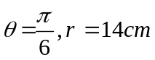 26. 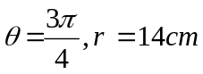

5.3 Circular Functions

Unit Circle:
45°

sin = cos = tan =

Notice since x = cos and y = sin
x+ y = 1 so sin² + cos² = 1 is an Identity

Notice since sin = y that sine is positive in quadrant one and two.

Also cos is = x and that is positive in quadrant one and four.

Since tangent is = 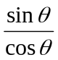 it is positive in one and three.

- Find each value:

  - sin π b) cos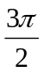 c) cos -90° d) sin 90°

- Sine and Cosine Functions of an Angle is Standard Position
For any angle in standard position with measure, a point P (x, y) on its terminal side, and 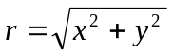, the sine and cosine functions of are as follows:

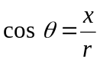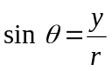

- Find the values of the sine and cosine functions of an angle in standard position with measure if the point with coordinates (5, 13) lies on its terminal side.

- Find the sin when 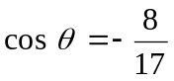 and the terminal side of is in the second quadrant.

- Suppose is in standard position with the given conditions. State the quadrant or quadrants in which the terminal side of lie.

- 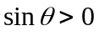 b. 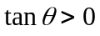 c. 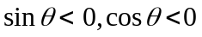 d. 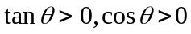

- The terminal side of an angle in standard position contains the point with coordinates (-3, -3).
Find sin, cos, and tan.

- The terminal side of an angle in standard position contains the point with coordinates (3, -4).
Find tan, sin, cos, and tan.

- If cos =  and lies in Quadrant IV, find sin and tan .

- If 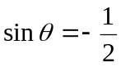and lies in Quadrant III, find cos and tan.

HW Page 260 # 23, 25, 27, 29, 30-32, 34-41 all

Pg 260
Find the values of the six trigonometric functions of an angle in standard position if the given point lies on the terminal side.
23. 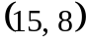 25. 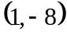 27. 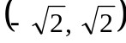 29. 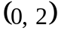

Suppose is an angle in standard position whose terminal side lies in the given quadrant. For each function, find the values of the remaining five trigonometric functions of
31. 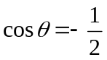; Quadrant II 33. 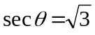; Quandrant IV

Find each exact value. Do not use calculator.

34. 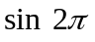 35. 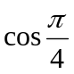 36. 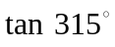 37. 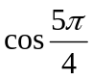

38. 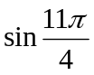 39. 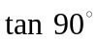 40. 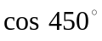 41. 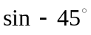

Day 4 In Class Name_______________________________

I. Given the angle find the following:

Quadrant______________ Reference Angle______________

Coterminal Angle(-)______________ Ordered Pair _______________

II. Given the angle find the following:

Quadrant______________ Degrees ______________

Reference Angle ______________ Coterminal Angle(-) ______________

III. Given the point (-3, -5) find the following:

Quadrant_______________ 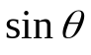_______________

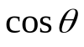_______________ 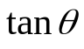_______________

 | Reference Angle or Ordered Pair | Quadrant or Axis | 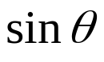 | 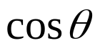 | 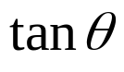
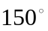
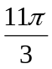
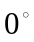
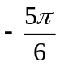
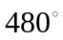
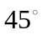
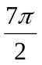
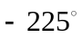
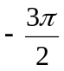

5.4 Trigonometric Functions of Special Angles
1. Find the values of the three trigonometric functions for an angle in standard position that
measures 180°.

2. Find sin 30°, cos 30°, and tan 30°.

3. Measure of Special Angles:
(in radians) | 0 | π  6 | π  4 | π  3 | π  2 | 2π  3 | 3π  4 | 5π  6 | π
(in degrees)
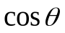
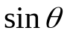

(in radians) | 7π  6 | 5π  4 | 4π  3 | 3π  2 | 5π  3 | 7π  4 | 11π  6 | 2π
(in degrees)

1. Find each value.
  - sin 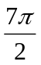 b. tan 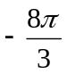 c. cos 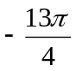

2. Find each value.
  - tan 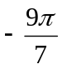 b. sin 321° c. cos 2.1π

HW page 267 #16-18, 22,23, 25, 28, 30, 33-35; Practice Unit Circle

Pg. 267 # 15 - 34
Find each exact value. Do not use calculator.
15. 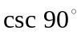 16. 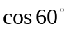 17. 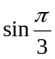 18. 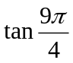

19. 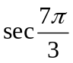 20. 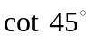 21. 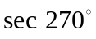 22. 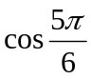

23. 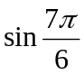 24. 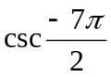 25. 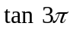 26. 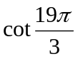

Use a calculator to approximate each value to four decimals. Be careful about the MODE!
27. 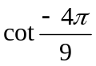 28. 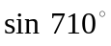

29. 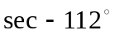 30. 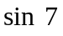

31. 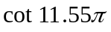 32. 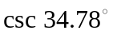

33. 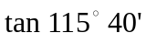 34. 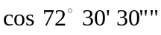

5.5 Right Triangles

- For an acute angle A in right triangle ABC, the trigonometric functions are as follow:

sin A = side opposite csc A = hypotenuse
hypotenuse side opposite

cos A = side adjacent sec A = hypotenuse
hypotenuse side adjacent

tan A = side opposite cot A = side adjacent
side adjacent side opposite

SOH-CAH-TOA

- A right triangle has sides whose lengths are 8 cm, 15 cm, and 17 cm. Find the values of the six trigonometric functions of α.

- In triangle RST, find the measure of ∠R to the nearest degree.

T
S
R
8
14

4. Find the measure of in each triangle.

HW: page 273: 15-23 odd, 29, 31; Practice 5.4 Worksheet

Pg 273 #15 - 23, 29, 30

Solve each triangle described, given the triangle below. Round angle measures to the nearest minute and the sides to the nearest tenth.

15. 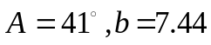

a
b
c
B
C
A

16. 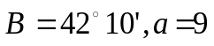

17. 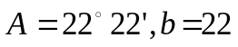

18. 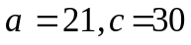

19. 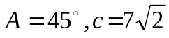 20. 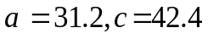

21. 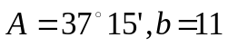 22. 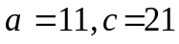

23. 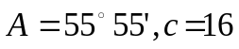 24. 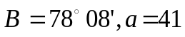

29. Home Maintenance Mrs. James is using a 6-meter ladder to clean the windows on her second floor. Her ladder stands on level ground and rests against the side of her house at a point 4 meters from the ground. How far from the side of her house is the foot of the ladder? Round your answer to the nearest hundredth.

30. Aeronautics A hot air balloon rises at the rate of 70 ft. per minute. An observer 420 ft. from the place of ascent watches the balloon rise. What is the angle of elevation to the nearest minute after 3.5 minutes?

5.4 Practice Worksheet Circular Functions
Find the values of the six trigonometric functions of an angle in standard position if the given point lies on the terminal side.
1. 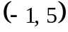 2. 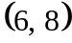 3. 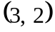 4. 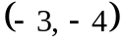

5. 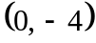 6. 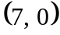 7. 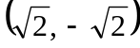 8. 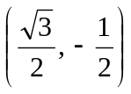

Suppose is an angle in standard position whose terminal side lies in the given quadrant. For each function, find the values of the remaining five trigonometric functions of
9. 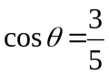; Quadrant IV 10. 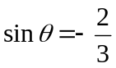; Quandrant IV

Find each exact value. Do not use calculator.
1. 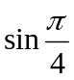 2. 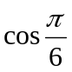 3. 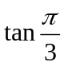 4. 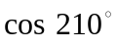

5. 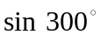 6. 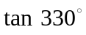 7. 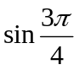 8. 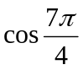

9. 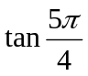 10. 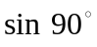 11. 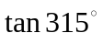 12. 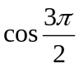
13. 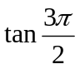 14. 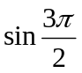

Use a calculator to approximate each value to four decimal places.
15. 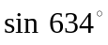 16. 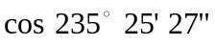 17. 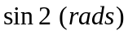 18. 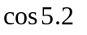

6.2 Graphs of Sine and Cosine Functions with Amplitude and Period Changes
- Graph of 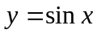

- Graph of 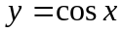

- Definition of Amplitude of Sine and Cosine Curves
The amplitude of 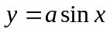 and 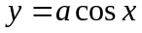 represents half the distance between the maximum and the minimum values of the function and is given by Amplitude = 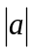.

- Determine the amplitude of each, then graph.
a. 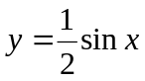 b. 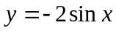 c. 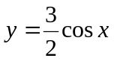 d. 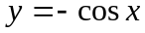

- Period of Sine and Cosine Functions
Let b be a positive real number. The period of 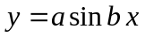 and 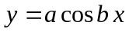is given by 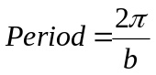

- Sketch the graph of each.
  - 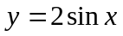

  - 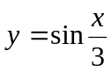

  - 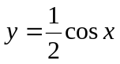

  - 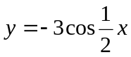

Homework: 6.2 Day 1 Worksheet
AFM 6.2 Day 1 Worksheet NAME ____________________
I. Determine the amplitude, b value, and period for each function.
Amplitude b – value Period
1. 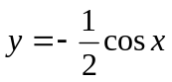
2. 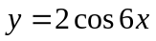
3. 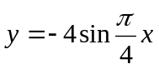
4. 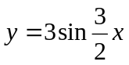
5. 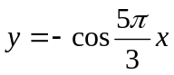
6. 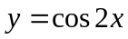

II. Find the following and then graph at least 1 cycle of each function on the grids provided.
a b Period
7. 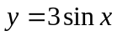
8. 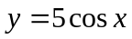
9. 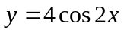
10. 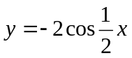
11. 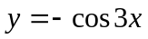
12. 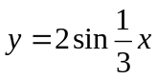

7. 8.

9. 10.

11. 12.

AFM 6.2 Day 1 Worksheet NAME ____________________
I. Determine the amplitude, b value, and period for each function.
Amplitude b – value period
1.
 | 1
2 | 6
4 |  | 8
3
5
1 | 2
2.
3.
4.
5. 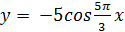
6.

II. Find the following and then graph at least 2 cycles of each function on GRAPH paper.
a b period
7.
3 | 1
5 | 1
4 | 2
2
1 | 3
2
8.
9.
10.
11.
12. 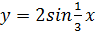

6.2 Graphs of Sine and Cosine Functions with Phase Shifts.
Phase Shift: For 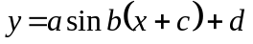 and 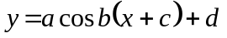,
The amplitude is 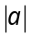. The period is 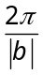.
The phase shift is c units to the left if c > 0, and 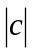 units to the right if c < 0.
- Graph each of the following.
  - 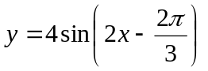

  - 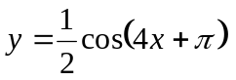

Vertical Shifts: The vertical shift from 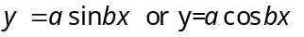 is d up if d > 0,
and d units down if d < 0.
- Graph each of the following:
  - 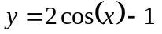 b. 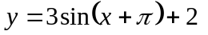

Homework: page 315-316 #15-22, 26, 28, 34, 36, 38, 41, 42, Worksheet
AFM 6.2 Day 2 Worksheet NAME _____________________________

I. Determine the amplitude, b value, period, phase shift and vertical shift for each function.
a b p PS VS
1. 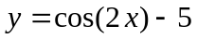
2. 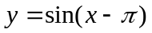
3. 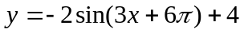
4. 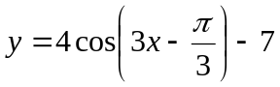
5. 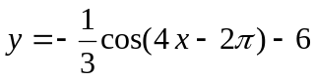
6. 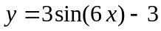

II. Find the following and then graph at least 1 cycle of each function on the grids provided or your own paper.
a b p PS VS
7. 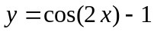
8. 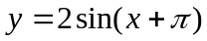
9. 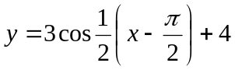
10. 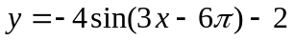

7. 8.

9. 10.

AFM 6.2 Day 2 Worksheet NAME ____________________

- Determine the amplitude, b value, period, phase shift and vertical shift for each function.
a b p PS VS
1 | 2 |  | None | Down 5
1 | 1 |  | Right | None
2 | 3 |  | Left | Up 4
4 | 3 |  | Right | Down 7
 | 4 |  | Right | Down 6
3 | 6 |  | none | Down 3
1.
2.
3.
4. 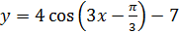
5. 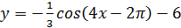
6.

- Find the following and then graph at least 2 cycles on GRAPH paper.
a b p PS VS
7.
1 | 2 |  | None | Down 1
2 | 1 |  | Left | None
3 |  |  | Right | Up 4
4 | 3 |  | Right | Down 2
8.
9. 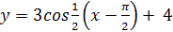
10.

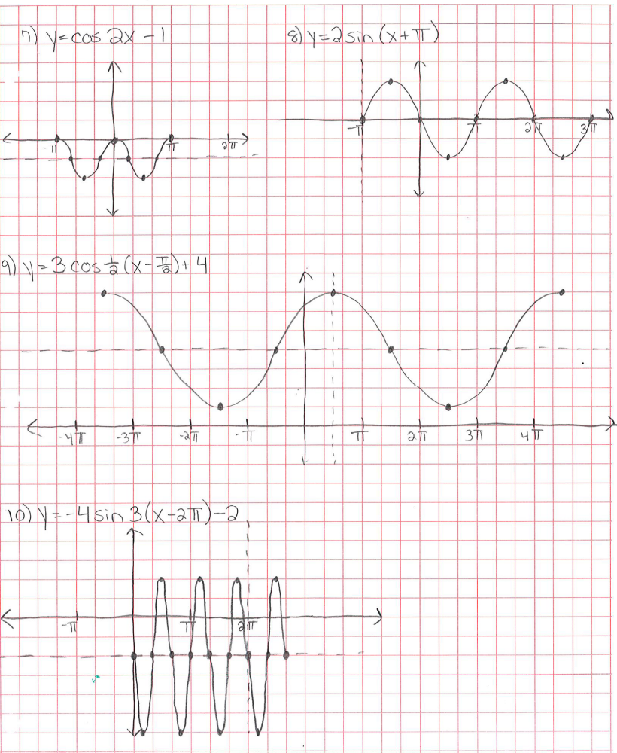

6.2 Day 3 Notes Writing Cosine and Sine Equations From a Graph
- Find the amplitude by taking half of the vertical distance between the minimum and the maximum.

- Find the period by finding how long the graph takes to complete one cycle.

- Find the vertical shift by finding the middle horizontal line between the minimum and the maximum.

- Find the phase shift for cosine by finding the distance between the y-axis and a maximum. Or a minimum but then you are multiplying equation by a negative.

- Find the phase shift for sine by finding the distance between the y-axis and a point on the x-axis (or shifted x-axis) that leads to a maximum right afterward.

- Pay ATTENTION to the SCALE used on the graphs!!

- Write equations in terms of cosine for the given graphs.
- b.
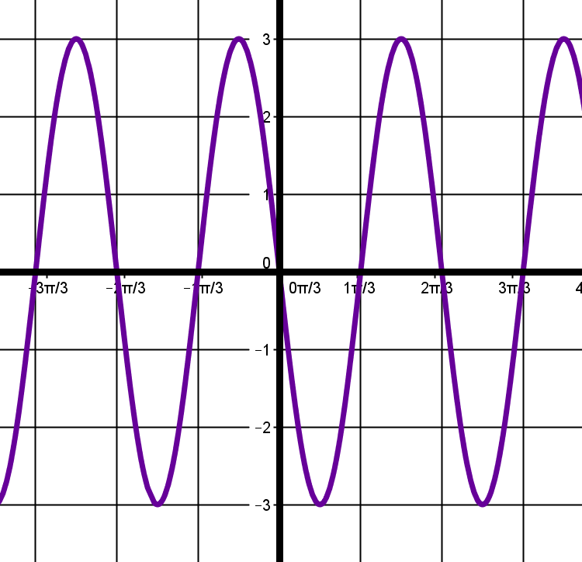
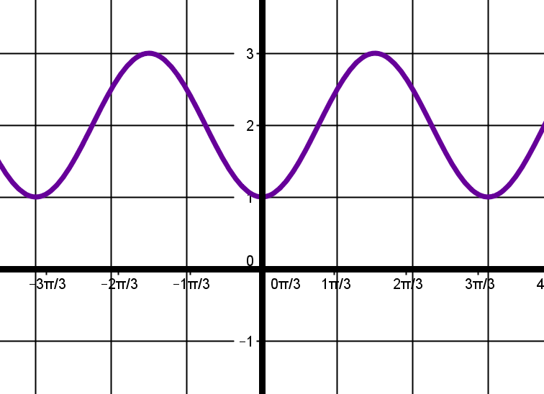

c. d.
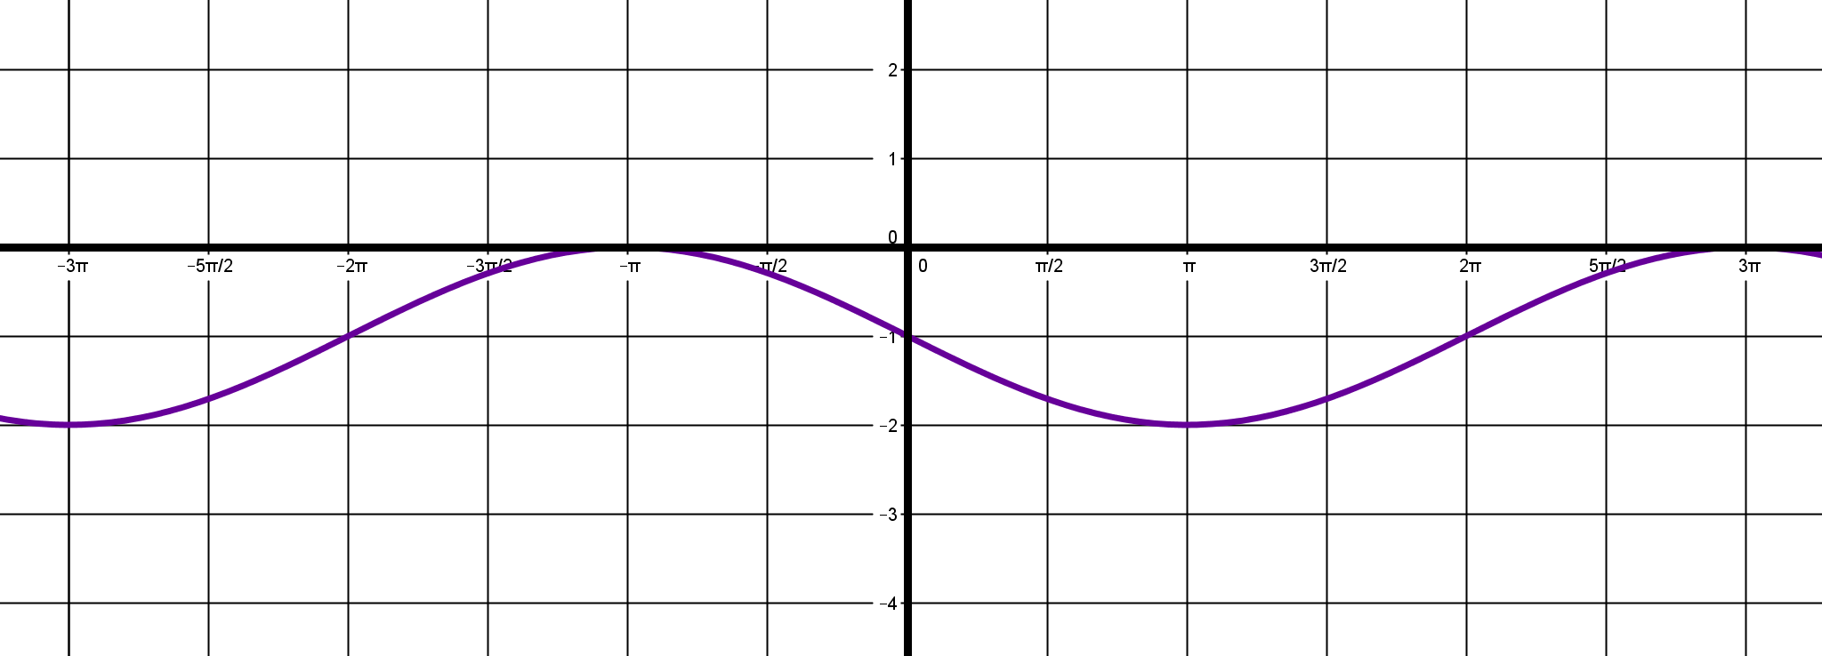
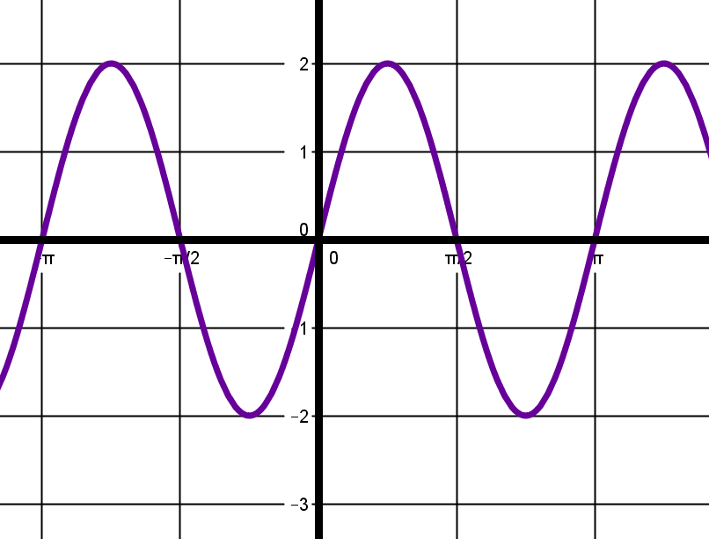

- Write equations in terms of sine for the given graphs.
- b.
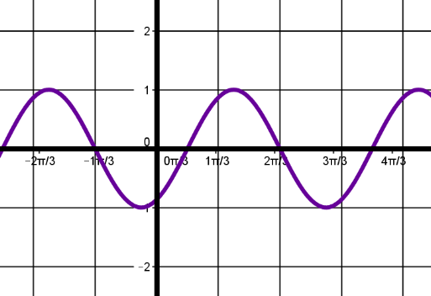
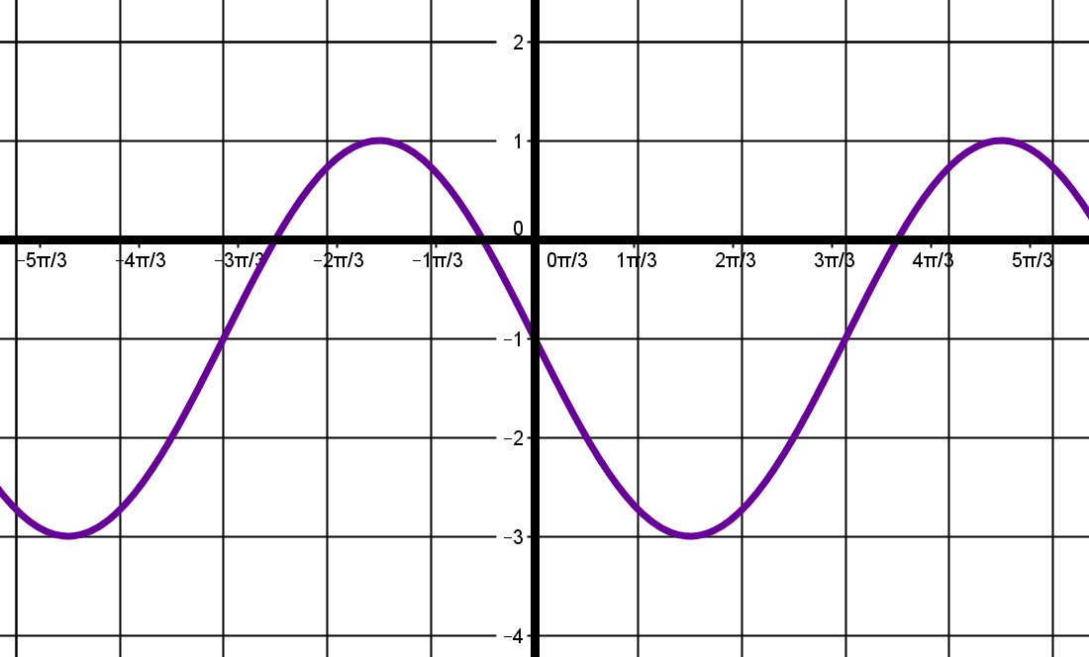

c. d.
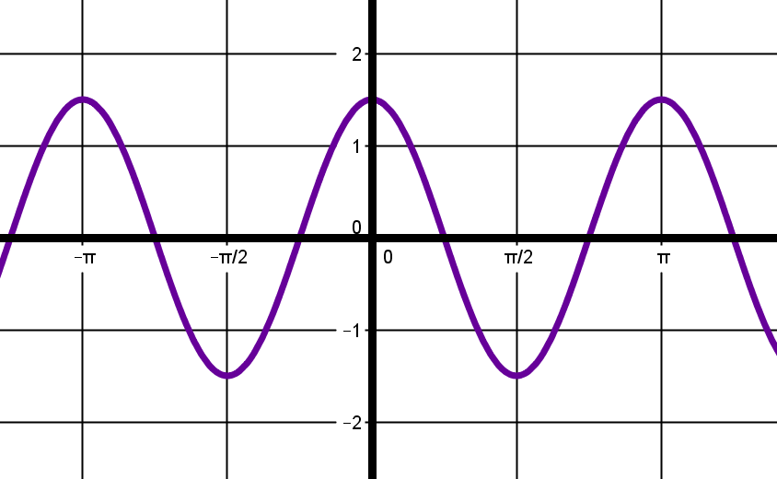
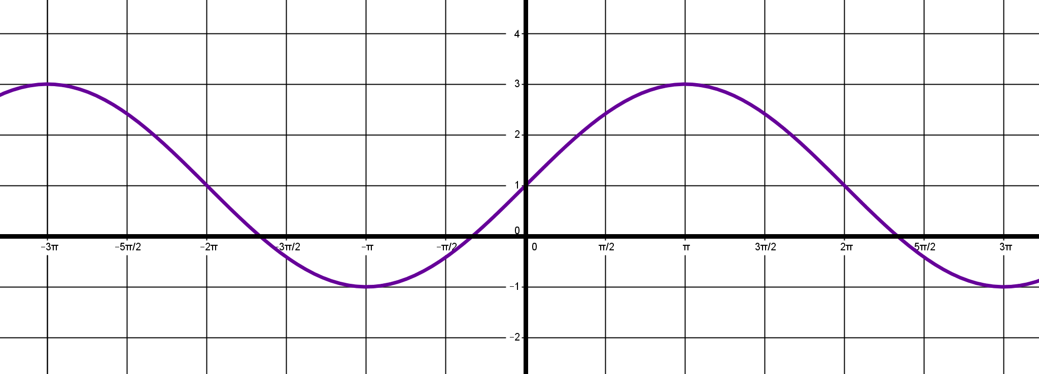

In Class: Write a sine and cosine equation for each graph.
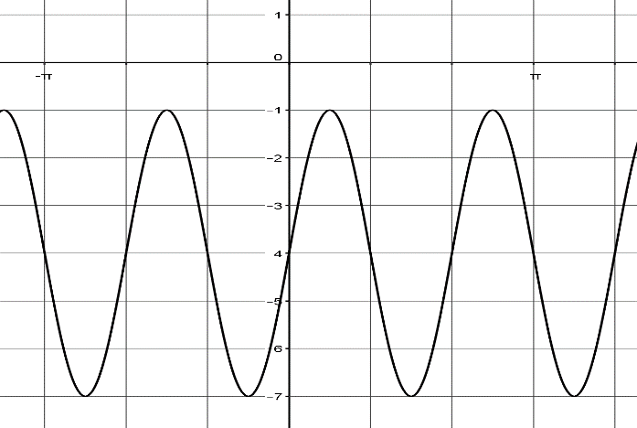
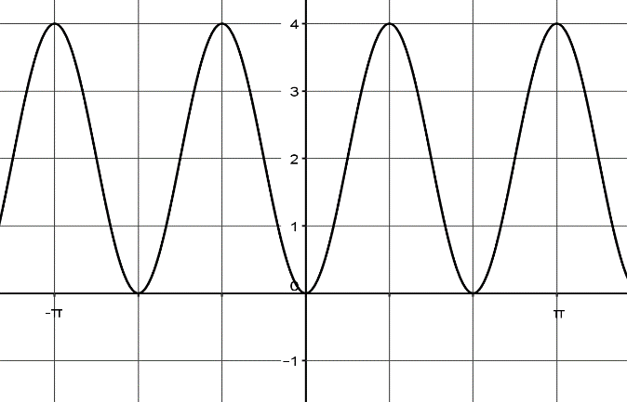
1. 2.

_________________________________________ ____________________________________________
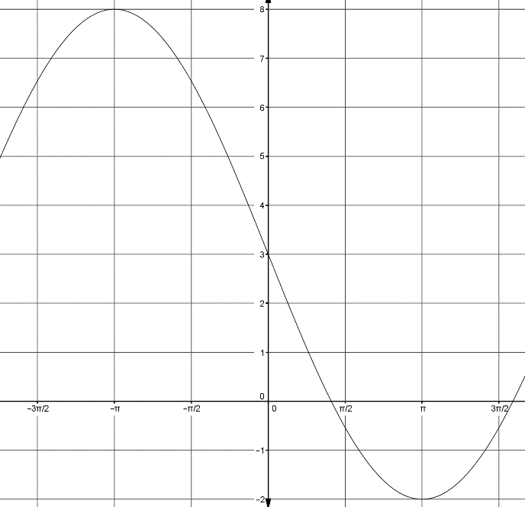
3. 4.

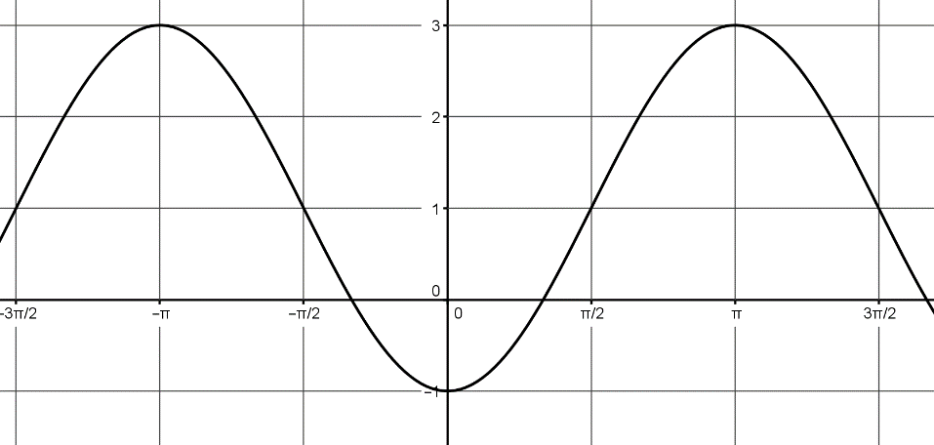

____________________________________________ ______________________________________
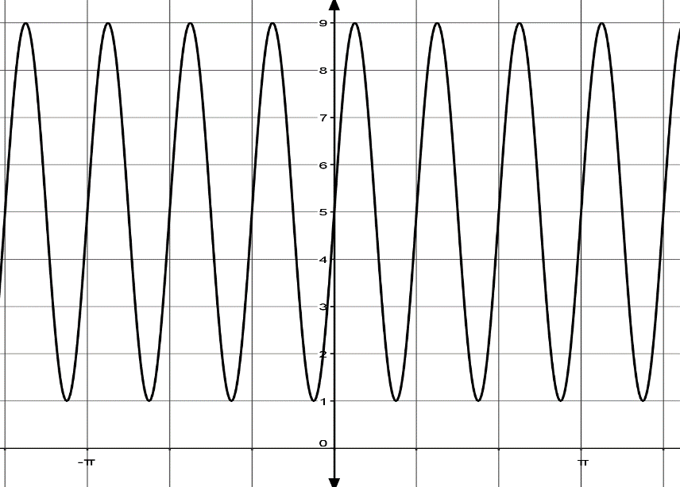
5. 6.
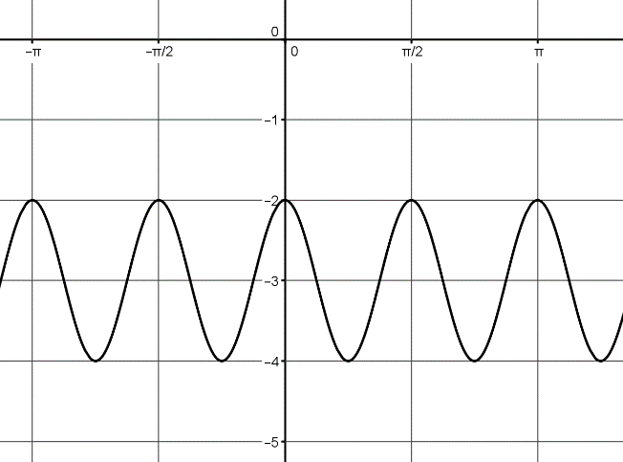

__________________________________________

___________________________________________________

6.2 Day 3 Worksheet
- Write the equation of each graph in terms of sine.
- 2.
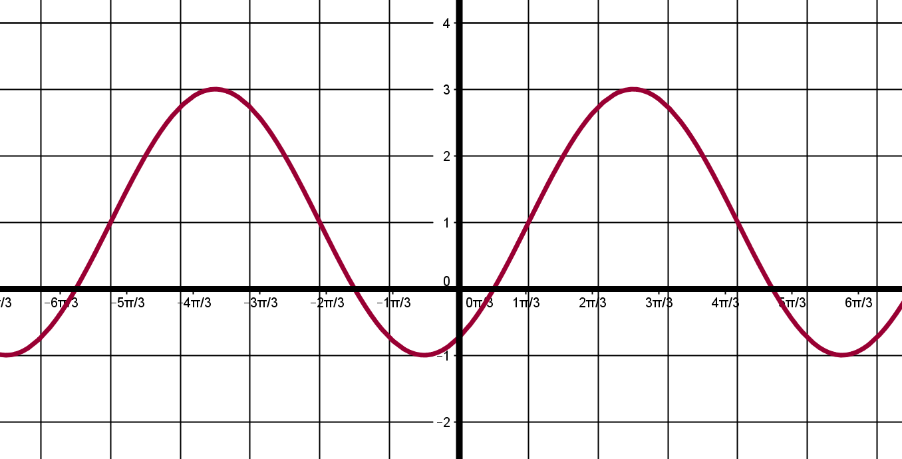
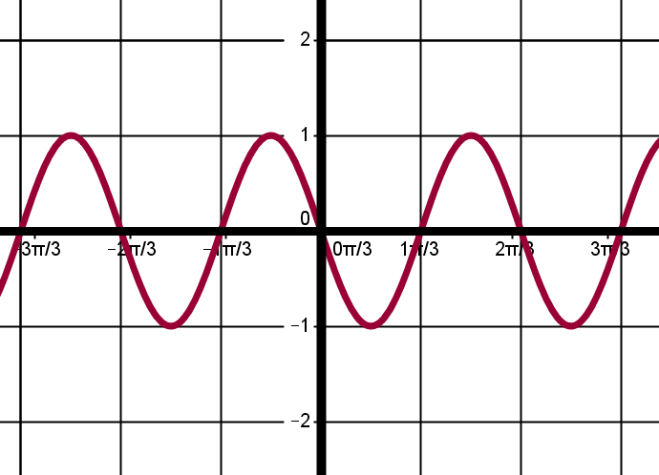

3. 4.
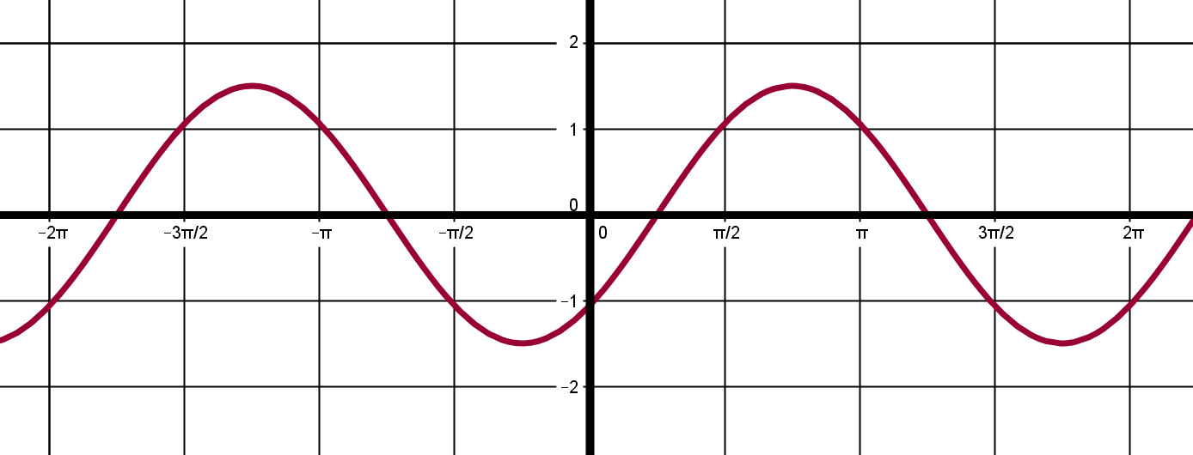
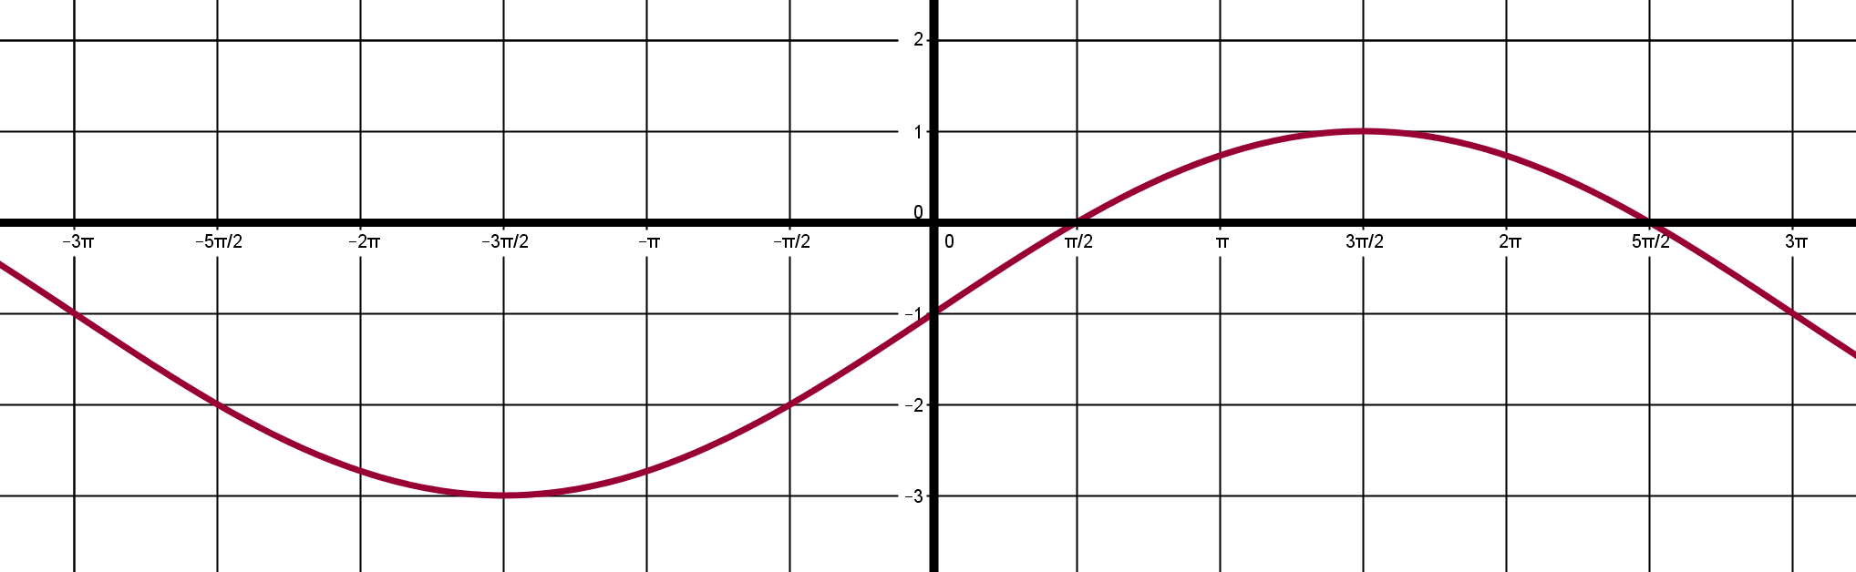

- Write the equation of each graph in terms of cosine.
5. 6.
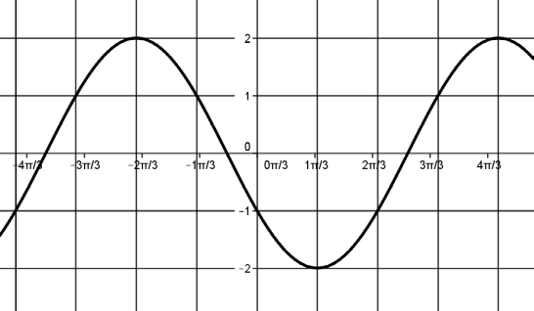
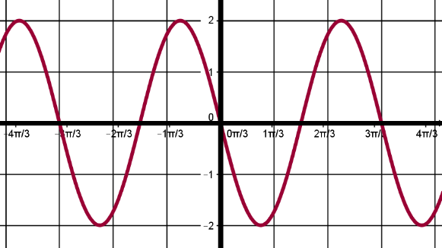

7. 8.
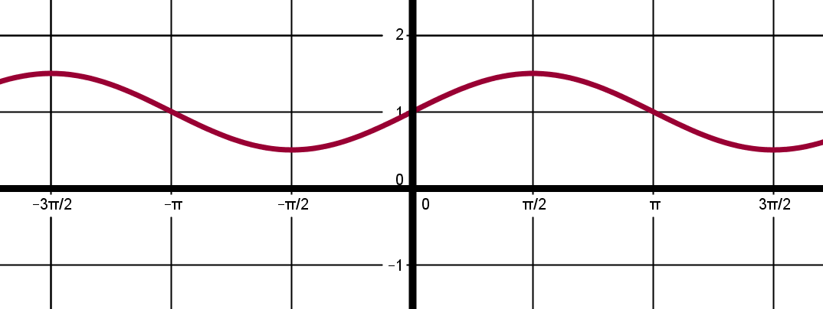
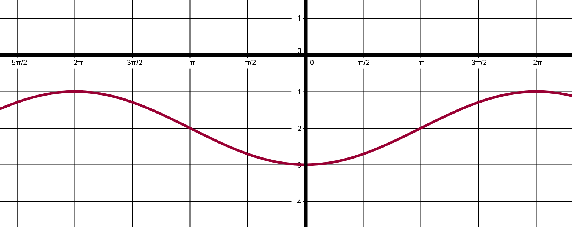

6.2 Day 4 Word Problems with Sine and Cosine Notes
- The initial behavior of the vibrations of the note E above middle C can be modeled by
- What is the amplitude of this model?

- What is the period of this mode?

- A rodeo performer spins a lasso in a circle perpendicular to the ground. The height of the knot from the ground is modeled by where t is the time measured in seconds.
- What is the highest point reached by the knot?

- What is the lowest point reached by the knot?

- What is the period of the model?

- According to the model, find the height of the knot after 25 seconds.

- The figure shows the depth of water at the end of a boat dock. The depth is 6 feet at low tide and 12 feet at high tide. On a certain day, low tide occurs at 6 A.M. and high tide occurs at noon. If y represents the depth of the water x hours after midnight, use a cosine function of the form to model the water’s depth.

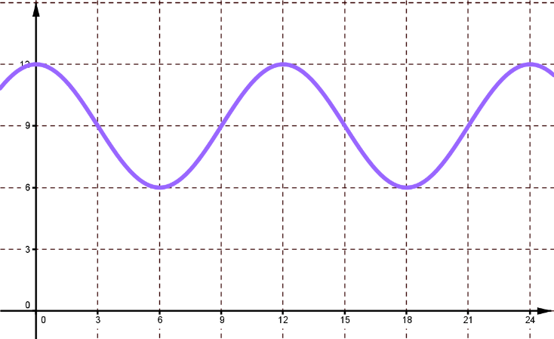

- An average seated adult breathes in and out every 4 seconds. The average minimum amount of air in the lungs is 0.08 liter, and the average maximum amount of air in the lunges is 0.82 liter. Suppose the lunges have a minimum amount of air at , where t is the time in seconds.
- Write a function that models the amount of air in the lungs.

- Determine the amount of air in the lungs at 5.5 seconds.

- The tide in a coastal city peaks every 11.6 hours. The tide ranges from 3.0 meters to 3.3 meters. Suppose that the low tide is at where t is the time in hours.
- Write a function that models the height of the tide.

- Determine the height of the tide at 6.2 hours.

- A Ferris wheel at an amusement park has riders get on at position A, which is 3 m above the ground. The highest point of the ride is 23 meters above the ground. The ride takes 40 seconds for one complete revolution. Write the equation that models the height of the Ferris wheel over time.
23 m

23 m
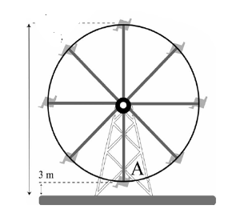

- A Ferris wheel has a diameter of 80 feet. Riders enter the Ferris wheel at its lowest point, 6 feet above the ground at time t = 0 seconds. One complete rotation takes 67 seconds. Write a function modeling a riders height, h(t), at t seconds.

6.2 Day 4 Word Problems with Sine and Cosine Worksheet
- If the equilibrium point is then models a buoy bobbing up and down in the water. Find the period of the function and the location of the buoy at

- The function where t is in months and corresponds to April 15, models the average high temperature in degrees Fahrenheit in Centerville.

- Find the period of the function.
- What does the period represent?
- What is the maximum high temperature?
- When does the maximum occur?

- The population of predators and prey in a closed ecological system tends to vary periodically over time. In a certain system, the population of owls O can be presented by where t is the time in years since January 1, 2001.
- Find the maximum number of owls.
- When does the maximum occur?
- Find the minimum number of owls.
- When does the minimum occur?

- A leaf floats on the water bobbing up and down. The distance between its highest and lowest point is 4 centimeters. It moves from its highest point down to its lowest point and back to its highest point every 10 seconds. Write a cosine function the models the movement of the leaf in relationship to the equilibrium point.

- A person’s blood pressure oscillates between 160 and 60. If the heart beats once every second, write a sine function that models this person’s blood pressure.

- Kala is jumping rope, and the rope touches the ground every time she jumps. She jumps at the rate of 40 jumps per minute, and the distance from the ground to the midpoint of the rope at its highest point is 5 feet. At the height of the midpoint is zero.
- Write a function for the height of the midpoint of the rope above the ground after t seconds
- Find the height of the midpoint of the rope after 32 seconds.

- Sam and Dan are being dared to ride the Ferris wheel The height h (in feet) above the ground at any time t (in seconds) can be modeled by:

a. Find the amplitude and period.
b. The Ferris wheel turns for 160 seconds before it stops to let Sam and Dan get off.
How many times will they go around?
c. What are the minimum and maximum heights for Sam and Dan?

- Suppose a Ferris wheel has a radius of 20 feet and operates at a speed of 3 revolutions per minute. The bottom car is 4 feet above the ground. Write a model for the height of a person above the ground whose height when t = 0 is 44 feet.

