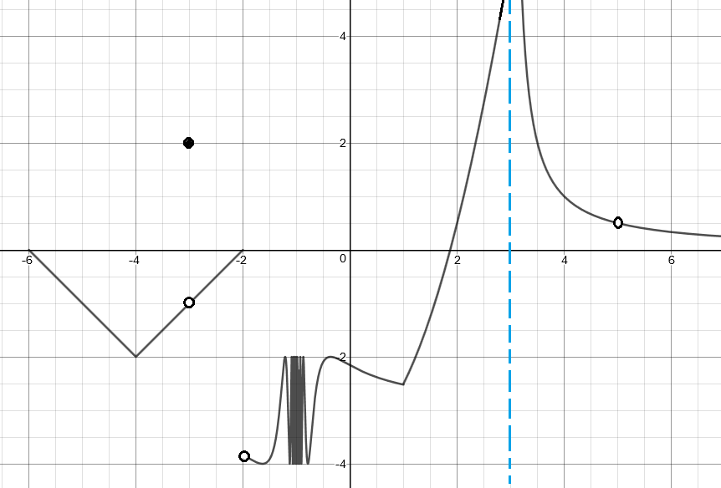
I. Use the pictured graph of g(x) for #1 and #2.

1. Evaluate each:
a) $\lim_{x→-1}{g(x)}$ b) $\lim_{x→5}{g(x)}$ c) $\lim_{x→-4}{g(x)}$ d) $\lim_{x→3}{g(x)}$

e) $\lim_{x→-3}{g(x)}$ f) $\lim_{x→1}{g(x)}$ g) $\lim_{x→-2}{g(x)}$ h) g(-3)

2. Determine whether or not the graph is continuous for each interval. Be sure to state why/why not.
a) [2,4] b) (-2,1) c) [0,3) d) [-6,-2]

II. Write a limit statement based on the table:
x | y
4.9 | 2.51
4.99 | 2.9501
4.999 | 2.995
5 | DNE
5.0001 | 3.0005
5.001 | 3.005
5.01 | 3.0501
x | y
1.9 | -.995
1.99 | -.9995
1.999 | -.99995
2 | DNE
2.001 | -.99995
2.01 | -.9995
2.1 | -.995
3. 4.

III. Evaluate each:
5. $\lim_{x→0}{\frac{\sec{7x}}{\csc{4x}}}$ 6. $\lim_{x→0}{\frac{17\sin{10x}}{x}}$ 7. $\lim_{x→0}{\frac{x^{2}-9x-10}{x^{2}-1}}$
8. $\lim_{∆x→0}{\frac{5{(x+∆x)}^{2}+1-(5x^{2}+1)}{x}}$ 9. $\lim_{h→0}{\frac{\frac{2}{x+h-3}-\frac{2}{x-3}}{h}}$ 10. $\lim_{x→11}{\frac{\sqrt{x+5}-4}{x-11}}$
11. $\lim_{x→3 }\left[x\right]-x$ 12. $\lim_{x→7}{\frac{7-x}{x^{2}-49}}$ 13. $\lim_{x→∞}{\sqrt[5]{\frac{32x^{8}-9x^{2}+3}{7+x^{8}}}}$
14. $\lim_{x→-∞}{\frac{x^{5}+3x^{2}-8}{x^{2}+4x^{7}-1}}$ 15. $\lim_{x→8^{-}}{\frac{x+8}{x^{2}-64}}$ 16. $\lim_{x→∞}{\frac{-x^{9}+2x^{4}-3}{x^{4}+5}}$
17. $\lim_{x→-∞}{\frac{\sqrt{4x^{2}+1}}{x-6}}$ 18. $\lim_{x→∞}{\frac{\sqrt{4x^{2}+1}}{x-6}}$ 19. $\lim_{x→0}\left|x\right|\sin{x}$
20. $\lim_{x→0^{+} }4-{\frac{1}{x^{2}}}$ 21. $\lim_{x→∞}{\frac{19x^{2}}{{(x^{16}-2)}^{1/4}}}$ 22. $\lim_{x→∞}{\frac{x-\cos{x}}{x}}$
23. Find $\lim_{x→8}{f(x)} if \frac{x^{2}-7x-8}{x-8}≤f\left(x\right)≤x^{2}-55$
IV. Is the function continuous at x = 15? Be sure to justify, citing your definition of continuity.
24. $g\left(x\right)=\left\{\begin{aligned}\frac{x^{2}-13x-30}{x^{2}-15x} if x≠15 \\ \frac{1}{225}x+\frac{16}{15} if x=15\end{aligned}\right.$

25. $p\left(x\right)=\frac{1}{x-15}$

26. $r\left(x\right)=\left\{\begin{aligned}\frac{2x^{2}-31x-15}{x^{2}-225} if x≠15 \\ x+3 if x=15\end{aligned}\right.$
V. AP Practice:
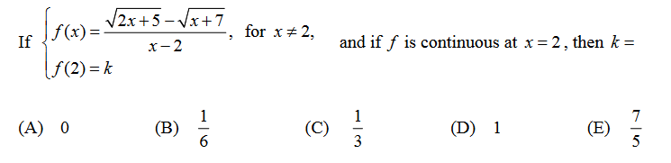
27.

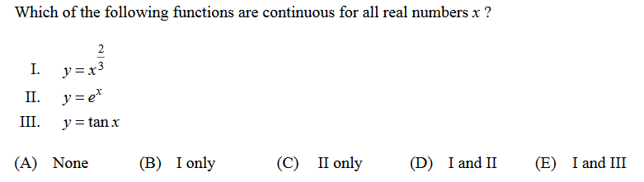
28.

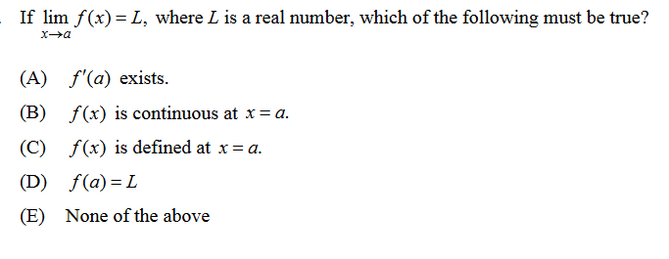
29.

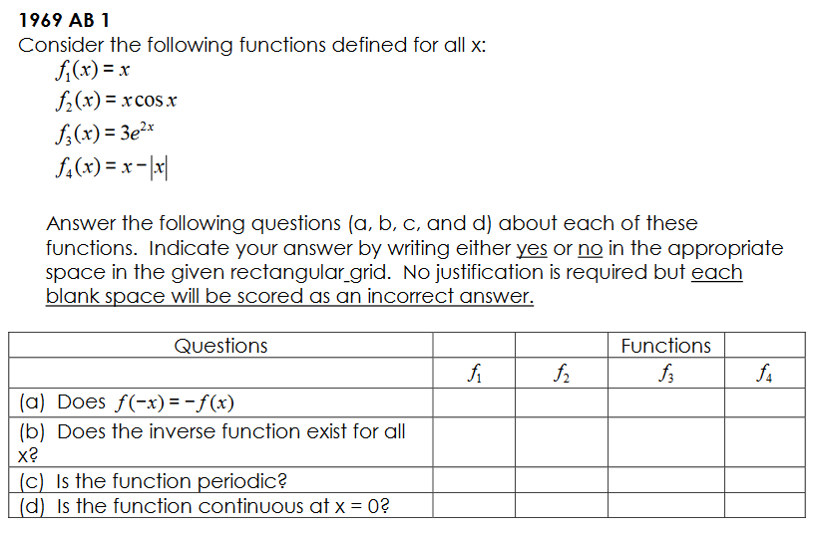
30.

