AFM Midterm Review I Fall 2016

1. Determine if the relation is a function. $\{\left(1,6\right),\left(-3,3\right),\left(5,-1\right)\}$
2. Determine the domain of the function $h\left(x\right)=\frac{7x}{x(x^{2}-4)}$.
3. Sketch the graph of $f\left(x\right)-\left|x-2\right|.$



1. Sketch the graph of $f\left(x\right)=\left[x+2\right].$



1. Sketch the graph of $f\left(x\right)=\left[x\right]+1.$



1. Find the vertical, horizontal, and slant asymptotes, if any, for $f\left(x\right)=\frac{{2x}^{3}+{2x}^{2}-7x-12}{x^{2}-x-2}$.
2. Given that one zero is $-2$, find all the zeroes of $P\left(x\right)=x^{3}+{11x}^{2}+38x+40.$
3. Find the number of complex roots of the equation $-x^{3}-{4x}^{2}-3x=0$.



Then find the roots and graph the related function.

1. Find the discriminant and determine the number and kind of roots for ${4x}^{2}-4x-24=0$.
2. Divide using synthetic division: $\left(x^{3}-{4x}^{2}-16x+64\right)÷\left(x+4\right).$
3. Use the rational-root theorem to find the roots of the equation ${24x}^{3}+{14x}^{2}-x-1=0.$
4. Find all the zeros of the function for $f\left(x\right)={6x}^{4}+{5x}^{3}-{12x}^{2}-5x+6.$
5. Convert $30°$ to radians.
6. Convert $\frac{5}{6}π$ to degrees.
7. Find the least positive angle measurement that is coterminal to $-\frac{4}{3}π$.
8. What is the reference angle for $-\frac{53π}{10}$ radians?
9. For a circle of radius 4 feet, find the arc length s subtended by a central angle of $30°$.
10. Find the area of a sector with a central angle of $\frac{8π}{9}$ and a radius of 8.2 m. Round the answer to one decimal place.
11. Find $\sin{θ}$ if $θ$ is an angle is standard position and the point with coordinates $(4,3)$ lies on the terminal side of the angle.
12. Find $\cos{θ}$ if $θ$ is an angle in standard position and the point with coordinates $(3,-4)$ lies on the terminal side of the angle.
13. Find $\tan{θ}$ if $θ$ is an angle in standard position and the point with coordinates $(-12,5)$ lies on the terminal side of the angle.
14. Find the values of the three trigonometric functions of an angle in standard position and the point with coordinates $(2,4)$ lies on the terminal side.
15. Find the values of the three trigonometric functions of an angle in standard position if the point with coordinates $(-2,0)$ lies on the terminal side.
16. Find $\cos{(-\frac{7}{6}π)}$.
17. Use a calculator to approximate the value of $\cos{(-113°)}$ to four decimal places.
18. In right triangle ABC, $A=15°$ and $c=37$. Angle C is the right angle. Solve the triangle. Round angle measures to the nearest minute and side measures to the nearest tenth.
19. In right triangle ABC, and . Angle C is the right angle. Solve the triangle. Round angle measures to the nearest minute and side measures to the nearest tenth.
20. In right triangle ABC, and . Angle C is the right angle. Solve the triangle. Round angle measures to the nearest minute and side measures to the nearest tenth.
21. In right triangle ABC, and . Angle C is the right angle. Solve the triangle. Round angle measures to the nearest minute and side measures to the nearest tenth.
22. In right triangle ABC, and . Angle C is the right angle. Solve the triangle. Round angle measures to the nearest minute and side measures to the nearest tenth.
23. How many triangles are there that satisfy the conditions $a=7,b=8, A=70°$?
24. Solve triangle ABC given that $A=54°,B=56°$ and $b=73$.
25. Given a triangle with $b=5,c=9,$ and $A=110°$, what is the length of *a*? Round the answer to two decimal places.
26. Find the area of the triangle with $A=98°,b=2$ feet and $c=7$ feet.

Round your answer to two decimal places.

1. Use the graph of the cosine function below to find the values $θ$ of for which .



1. State the amplitude and period for the function $y=-5\sin{\frac{1}{5}θ}.$
2. Find a cosine function of the form $y=Acos \left(Bx+C\right), A>0$, a portion of whose graph is:



1. The function below determines the amount of yearly income tax a person must pay based on the amount of money they earn in a year.
$$T\left(x\right)=\left\{\begin{matrix}0.10x 0≤x<12,750 \\ 0.07\left(x-12,750\right)+ 765 12,750≤x<60,000 \\ 0.0775\left(x-60,000\right)+4,072.50 x≥60,000 \end{matrix}\right.$$

2. Describe what x and T(x) represent in the context of the problem.
3. Write the domain and range in interval notation.
4. Explain your tax rate (i.e. the % you pay) if you make:
5. less than $12,750 per year
6. $12,750 to $59,999 per year
7. $60,000 per year or more

**Make sure to review your Unit Circle. Be ready for no calculator questions on Regular Trigonometry**

AFM Fall 2016 Graphing Calculator Active

Midterm review II

1. Solve for x: .

2. Determine the equation whose roots are 2, 9 and -4.

3. Suppose $f\left(x\right)=x^{3}-2x^{2}+13x+k.$ The remainder when *f*(x) is divided by (x + 1) is -8.

What is the remainder when *f*(x) is divided by (x – 1)?

4. Which of the following is NOT a factor of ? $2x^{4}-3x^{2}+1 ?$

A. x + 1 B. x – 1 C. 2x – 1

5. Write the polynomial equation of least degree for the roots 2*i*, -2*i* and -4.

6. Find the domain for: 

7. Find all asymptotes and holes for #6.

8. Find the x and y intercepts of  .

9. Find the smallest positive co-terminal angle with an angle measuring -213º.

10. Change -62º 11’ 45” to radian measure. Round answer to 4 places.

11. Change 1.24 radians to degrees. Round to 4 places.

12. Find the degree measure to the nearest tenth, of a central angle whose intercepted arc measures 16in

for a circle with radius 12in.

13. Find the area to the nearest tenth, of a sector whose central angle measures 105º if the radius

of the circle is 4.2 in.

14. Find the reference angle for an angle measuring -124º.

15. Describe the transformations in order then graph: 

16. Describe the transformations in order then graph: 

17. Find the amplitude, period, phase shift and vertical shift: 

18. Find the amplitude, period, phase shift and vertical shift: 

19. Write a sine and cosine equation for the following graph:



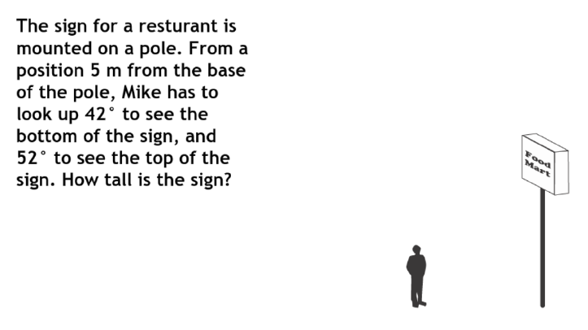

20. 21. Graph on graph paper:

