I. Find each Limit
1. $\lim_{x→2}{\frac{x^{2}-4}{x-2}}$
2. $\lim_{x→3}{\frac{x^{2}+2x-15}{x-3}}$
3. $\lim_{x→4}{\frac{x^{2}+2x-24}{x^{2}-2x-8}}$
4. $\lim_{x→ -2}{\frac{x^{2}+5x+6}{x^{2}+6x+8}}$
5. $\lim_{x→2}{\frac{x^{3}-8}{x-2}}$
6. $\lim_{x→ -3}{\frac{x^{3}+27}{x+3}}$
7. $\lim_{x→1}{\frac{x^{3}-1}{x^{2}-1}}$
8. $\lim_{x→ -1}{\frac{x^{3}+1}{x^{2}-1}}$
9. $\lim_{x→25}{\frac{x-25}{\sqrt{x}-5}}$
10. $\lim_{x→1}{\frac{x-1}{\sqrt{x}-1}}$
11. $\lim_{x→9}{\frac{\sqrt{x}-3}{x-9}}$
12. $\lim_{h→0}{\frac{\sqrt{4+h}-\sqrt{4}}{h}}$
13. $\lim_{h→0}{\frac{\sqrt{25+h}-5}{h}}$
14. $\lim_{h→0}{\frac{\sqrt{16+h}-4}{h}}$
15. $\lim_{h→0}{\frac{10-\sqrt{100-h}}{h}}$
16. $\lim_{h→0}{\frac{\sqrt{x+h}-\sqrt{x}}{h}}$
17. $\lim_{h→0}{\frac{h}{\sqrt{x}-\sqrt{x-h}}}$
18. $\lim_{x→2}{\frac{\frac{1}{x}-\frac{1}{2}}{x-2}}$
19. $\lim_{x→5}{\frac{\frac{1}{x}-\frac{1}{5}}{x-5}}$
20. $\lim_{x→1}{\frac{\frac{1}{x}-1}{x-1}}$
21. $\lim_{h→0}{\frac{\frac{1}{x+h}-\frac{1}{x}}{h}}$
22. $\lim_{h→0}{\frac{\frac{1}{2+h}-\frac{1}{2}}{h}}$
23. $\lim_{h→0}{\frac{\frac{1}{5+h}-\frac{1}{5}}{h}}$
24. $\lim_{h→0}{\frac{\frac{1}{3}-\frac{1}{3+h}}{h}}$
25. $\lim_{x→2}{\frac{\frac{1}{x^{2}}-\frac{1}{4}}{x-2}}$
26. $\lim_{x→3}{\frac{\frac{1}{x^{2}}-\frac{1}{9}}{x-3}}$
II. Find each using the graph
1. Graph is continuous and smooth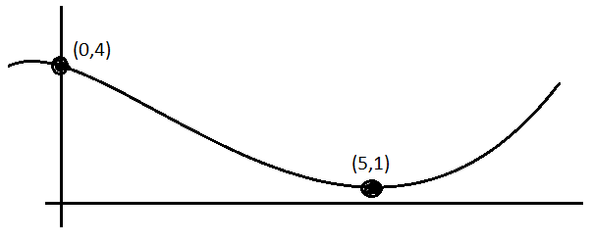 a) $\lim_{x→0}{f(x)}$ b) $\lim_{x→5}{f(x)}$

2. Graph is continuous and smooth
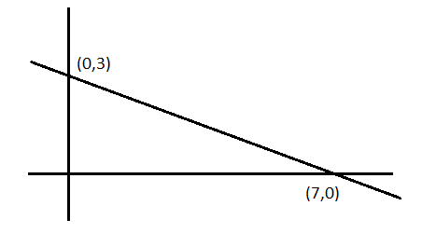
a) $\lim_{x→0}{g(x)}$ b) $\lim_{x→7}{g(x)}$
3. Graph has a sharp bend
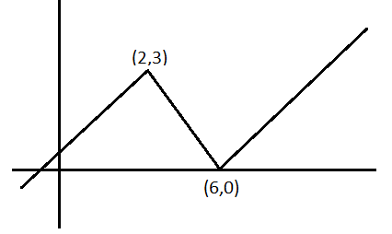
a) $\lim_{x→2}{h(x)}$ b) $\lim_{x→6}{h(x)}$

4. Graph has a sharp bend
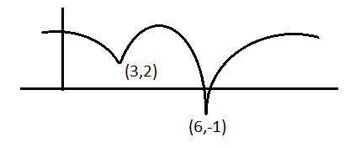
a) $\lim_{x→3}{f(x)}$ b) $\lim_{x→6}{f(x)}$

5. Graph has a sharp bend
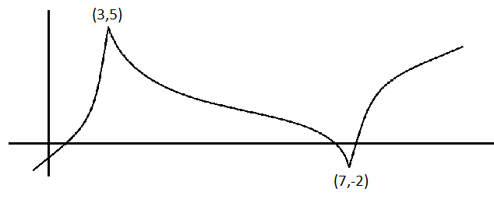
a) $\lim_{x→3}{s(x)}$ b) $\lim_{x→7}{s(x)}$
6. Graph has sharp bend
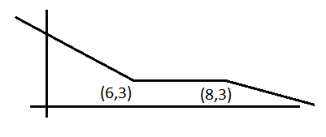
a) $\lim_{x→6}{f(x)}$ b) $\lim_{x→8}{f(x)}$

7. Graph has single point hole
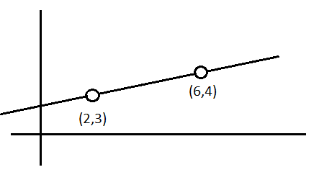
a) $\lim_{x→2}{g(x)}$ b) $\lim_{x→6}{g(x)}$

8. Graph has single point hole
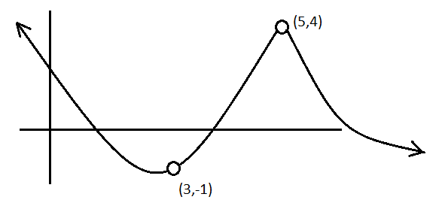
a) $\lim_{x→3}{h(x)}$ b) $\lim_{x→5}{h(x)}$
9. Graph has single point hole
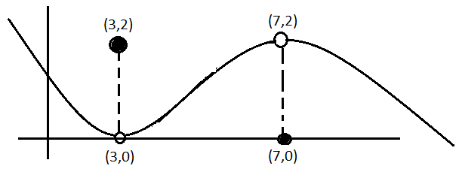
a) $\lim_{x→3}{f(x)}$ b) $\lim_{x→7}{f(x)}$
10. Graph has single point hole
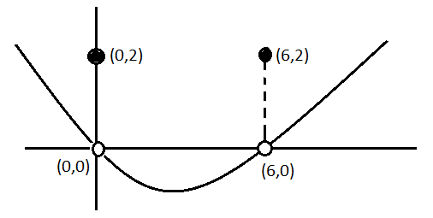 a) $\lim_{x→0}{g(x)}$ b) $\lim_{x→6}{g(x)}$

11. Graph has endpoints
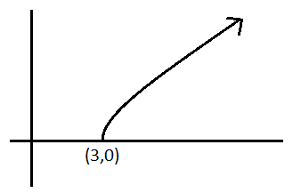
a) $\lim_{x→3^{+}}{g(x)}$
12. Graph has endpoints
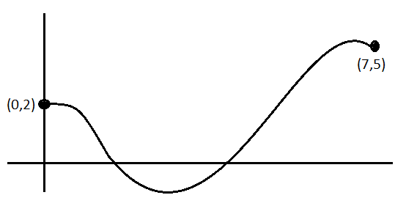
a) $\lim_{x→0^{+}}{f(x)}$ b) $\lim_{x→7^{-}}{f(x)}$
13. Graph has gap-jump
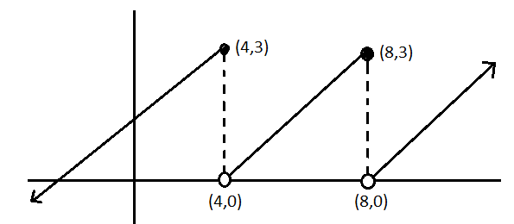
a) $\lim_{x→4}{f(x)}$ b) $\lim_{x→8}{f(x)}$
14. Graph has gap-jump
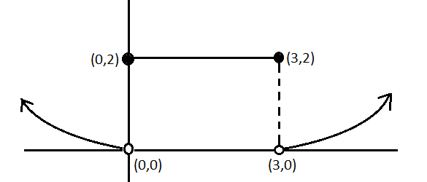
a) $\lim_{x→0}{g(x)}$ b) $\lim_{x→3}{g(x)}$

15. Graph has gap-jump
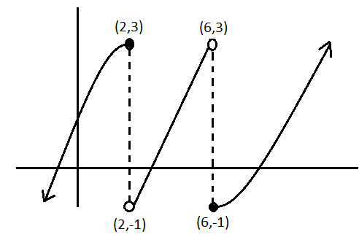
a) $\lim_{x→2}{k(x)}$ b) $\lim_{x→6}{k(x)}$
16. Graph has gap-jump
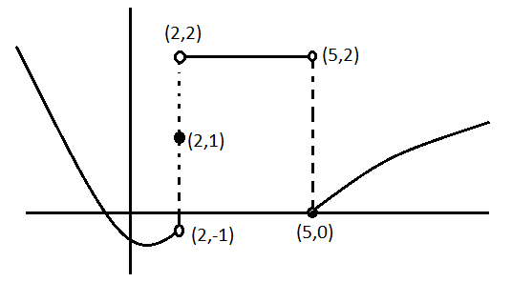
a) $\lim_{x→2}{t(x)}$ b) $\lim_{x→5}{t(x)}$

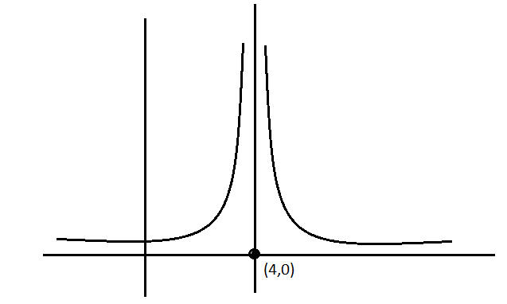
17. Graph tends to infinity

a) $\lim_{x→4}{f(x)}$

18. Graph tends to infinity
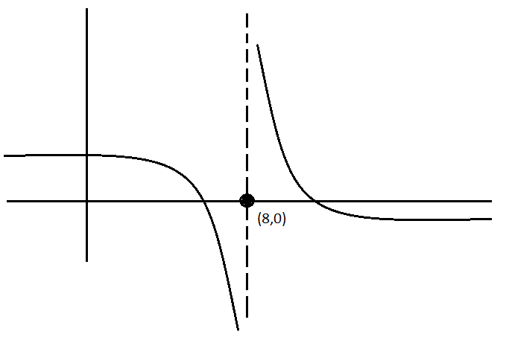a) $\lim_{x→8}{g(x)}$

19. Graph tends to infinity
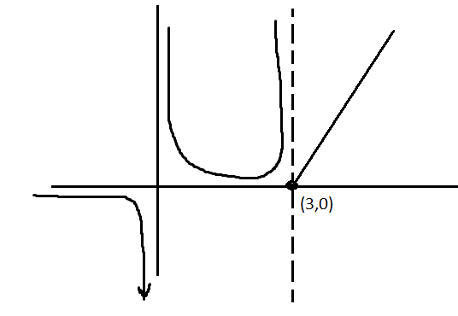
a) $\lim_{x→0}{f(x)}$ b) $\lim_{x→3}{f(x)}$

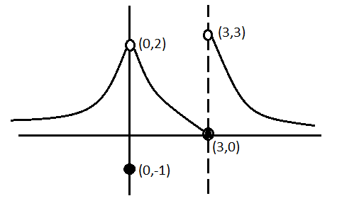
20.

a) $\lim_{x→0}{g(x)}$ b) $\lim_{x→3}{g(x)}$

21.
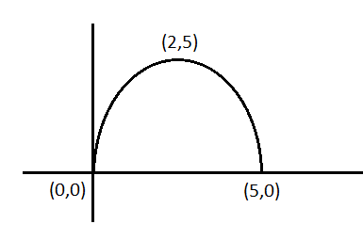
a) $\lim_{x→5}{h(x)}$ b) $\lim_{x→2}{h(x)}$
22. 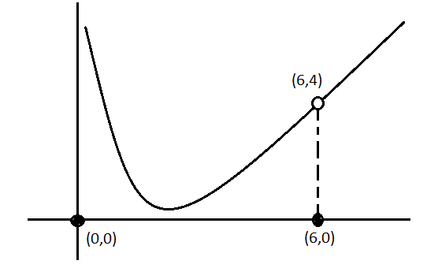
a) $\lim_{x→0}{m(x)}$ b) $\lim_{x→6}{m(x)}$
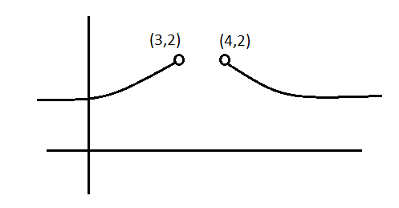
23.

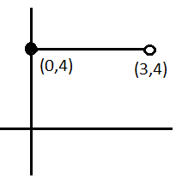
a) $\lim_{x→3}{r(x)}$ b) $\lim_{x→4}{r(x)}$
24.

a) $\lim_{x→0}{z(x)}$ b) $\lim_{x→3}{z(x)}$

